**Assignment No . 1**

**Subject :**

**C Sharp**

**Topic :**

**Form Design & Validation**

**Class :**

**MCS EVENING B**

**Roll .No :**

**SP20M2MB037**

**Submitted By:**

**Muhammad Saeed**

**Submitted To :**

**Sir Rehan Faheem sb**

**Simple Form Design**

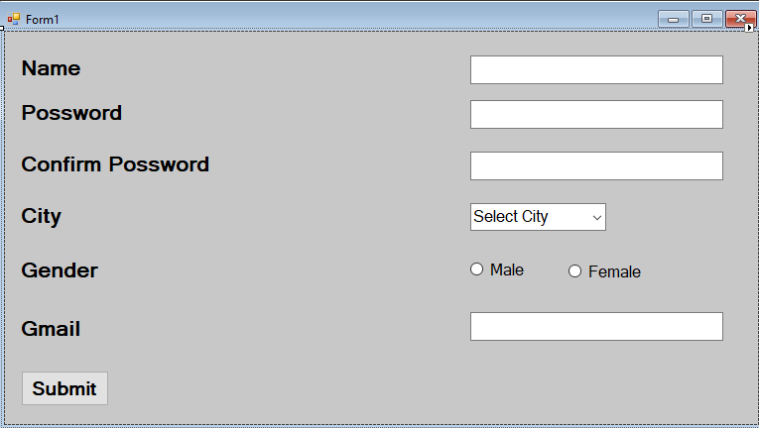

**Simple Form Validation**

private void textBox1_Leave(object sender, EventArgs e)

{

if (textBox1.Text.Length == 0)

{

MessageBox.Show("Please Enter your name");

textBox1.Focus();

}

}

private void textBox1_KeyPress(object sender, KeyPressEventArgs e)

{

if ((e.KeyChar >= '0' && e.KeyChar <= '9'))

{

e.Handled = true;

MessageBox.Show("Numbers are not allowed", " Please Enter alphabet");

}

}

private void textBox3_Leave(object sender, EventArgs e)

{

if (textBox2.Text.Length == 0)

{

MessageBox.Show("Please Enter your password");

textBox2.Focus();

}

}

private void textBox3_KeyPress(object sender, KeyPressEventArgs e)

{

if (!(e.KeyChar >= '0' && e.KeyChar <= '9'))

{

e.Handled = true;

MessageBox.Show("Alphabets are not allowed", " Please Enter number");

}

}

private void button1_Click(object sender, EventArgs e)

{

if (!radioButton1.Checked && !radioButton2.Checked)

{

MessageBox.Show("Please check one radio button!");

}

if (!(textBox4.Text.IndexOf("@") > -1 && textBox4.Text.IndexOf(".") > -1))

{

MessageBox.Show("enter a valid email address.");

}

}